Case study Template

Title of Case study / Good practice | CONNEMARA ATLANTIC SEAWEED COMPANY
Keywords (meta tag)
Provided by | EQUAL IRELAND
Language | ENGLISH
Case study
https://www.connemaraseaweedcompany.ie/
FROM THE WEST OF IRELAND
HAND HARVESTED ORGANIC SEAWEED
Noel Lee was born and raised in Lettermullen, a beautiful windswept Island off the West Coast of Ireland. For generations, the Lee family have been hand harvesting Kelp and Seaweed off the Connemara Coast.
OUR MISSION
Our mission is to provide hand harvested, sustainable, kelp and seaweed products for human consumption through health supplements and edible products. Having a positive impact on our community and our environment is at the core of all that we do.
WHAT DRIVES US
We aim to provide you with sustainably harvested, local, edible seaweeds and introduce these as an alternative food source that is healthy, nutritional, tasty, and good for the environment. It is important to acknowledge the importance of seaweeds for marine life, and we need to balance this with its use by humans. We, therefore, adopt an ecosystem approach, meaning that we promote conservation and sustainable use in an equitable way.
Most, if not all, the seaweeds currently for sale have travelled thousands of kilometres to reach your local supermarket and food shop. Small-scale, local produce is key to a happier life and leads to a lower carbon footprint. By providing food from our waters, we hope to contribute to a low-carbon economy that takes care of its environment. We hope and believe that seaweed becomes part of everyone’s diet and that we come to recognise it for what it is. A superfood, both environmentally and nutritionally!
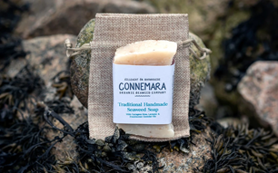
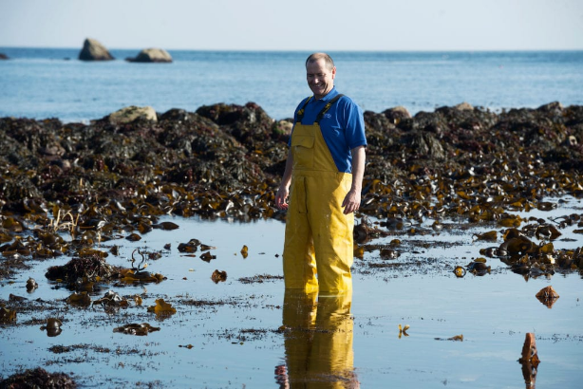
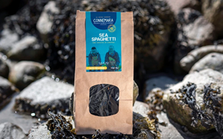

Reference Link (if any)
Type of material | CASE STUDY

