Í upphafi árs 2010 var maðurinn minn á netvafri kvöldsins þegar hann hnaut um söluauglýsingu á lítilli prjónastofu. Við nánari athugun reyndist þetta vera prjónastofa sem framleiddi vinnuvettlinga.
Áður en við vissum af vorum við búin að stofna fyrirtækið Vanda ehf (https://vanda.is)
Svo var það 2013 sem við sóttum um styrk til að vinna með markaðsmálin, gera okkar
Síðan þá hefur salan aukist og við styrkt okkur og lært af þessum rekstri á litla fjölskyldufyrirtækinu.
Mikil vinna hefur farið í þetta litla kvöld-netvafr hjá manninum mínum en það hefur líka gefið okkur hinar skemmtilegustu stundir saman. Börnin okkar hafa alist upp við að fjölskyldan vinni saman að þessu verkefni sem allir eiga sína hlutdeild í.

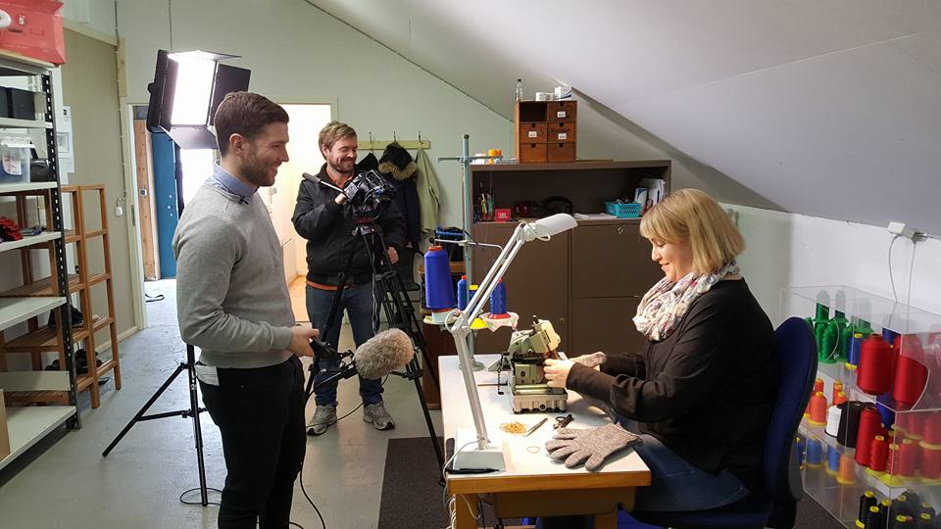

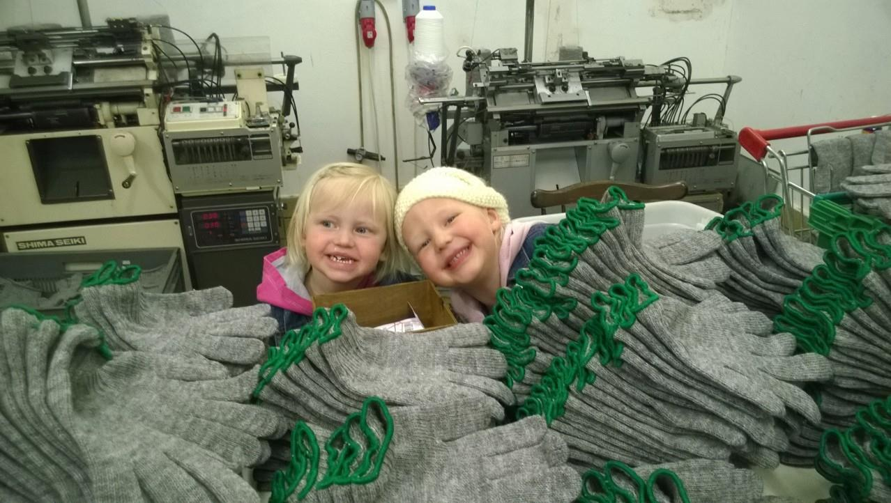

At the start of 2010, my husband was on his regular evening´s internet browsing when he stumbled across a sales advertisement for a small knitting salon. On a closer examination, this turned out to be a knitting salon that produced work mittens.
Before we knew it, we had founded the company, Vanda ehf., and bought this small knitting salon.
We knew little or nothing about this kind of knitting, and the machines were not exactly for amateurs.
The first year, a lot of time was spent on all kinds of mistakes and repairs and learning. We sold about 600 pairs and were happy and exhausted. We asked ourself regularly if we should continue to try this or give up. We decided to continue.
And in 2013 we applied for a grant to work with the marketing issues, make our logo and try to improve the markings on the product. We started promotional campaigns with potential customers and after 3-4 years we had sold 6000 pairs and the machines started working with us. Since then, sales have increased and we have strengthened ourselves and learned from this operation of the small family business.

A lot of work has gone into this little evening´s internet browsing with my husband, but it has also given us the most fun times together. Our children have grown up with the family working together on this project and everyone has a part in it.

