Sewing Sigga - Saumahorn Siggu

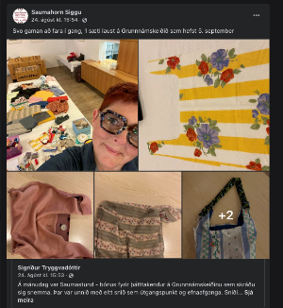

Sigríður Tryggvadóttir learned to sew at her mother's knee who sewed and altered clothes as was the customary back in the day. Her mothers advice was “My Sigga, if you take care to do the pattern well, it’s easy to sew a garment...”. Sigriður or Sigga, as she calls herself, began her sewing business when she became unable to work unable to work fulltime due to health issues. Sigga now specialises in giving courses and training on on altering and repairing clothes. She also also creates and markets her own designs.

Some of her courses take place in cooperation with the Icelandic Federation of Women's Associations (Kvenfélagasamband Íslands) and are a part of their awareness-raising project on Fast Fashion Waste. In these courses you can bring your own garments that require alterations and go through a process of getting ideas on how to do it best and then learning how to do it. Sigga also makes short educational videos and encourages people to combat clothing waste on her social media platforms. Her Facebook page is where she advertises her courses and that is where she showcases and markets her garments.

“For the last few years I have been specialising in the recycling of materials and love to alter old garments and make something new and unique out of them. This is very important to me today, with more environmental consciousness and knowing the effect of “fast fashion”. I am appalled by the overproduction of low quality clothing and textiles, and the mountains of clothing turned into waste. I believe that when we create our own clothes, sew, improve and alter them, we become more aware of the time and work involved in assembling a garment – and consequently reduce the purchase of cheap clothes made from poor materials.”

For a while, Sigga also worked on doing alterations and sewing for others, but has now branched out into sewing her own designs and giving courses. Her latest venture is creating dresses out of old veils no longer in fashion. None of her garments are identical but she makes garments in as many sizes as possible.
Sigga has a blog webpage with a guide and education section (https://saumahornsiggu.is ). Here she talks about the materials she uses, her sewing, her designs. She tells stories from her life, her health, her work routine but most are about unique sewing tasks. In many of her blogs there are photos, showing the processes, where her ideas come from and the final result. Sigga does not just write instructions with pictures but also publishes short youtube videos on her blog and on Facebook. “I think it’s a good idea to have a page like this, not just because of the sales potential because here I can let others keep track of what I’m doing – it also helps me. I often find my working capacity very low and it is good to check the blog and see what I have been doing. Maybe someone can learn something from me, or just enjoy reading and looking at pictures and watching the videos. “
